Digital Transformation Demo-Case
ESM – Efficient and Sustainable Manufacturing Pilot

Experiment Concept Note

Name of Experiment
Region
Contact

Table of Contents

DT Experiment Concept Note 3
Experiment Title 4
General description and motivation 4
Expected impact & benefits 4
Experiment domain 4
Involved Regions 4
Experiment Team 4
BUSINESS SCENARIO 5
AS-IS Scenario 5
Weaknesses and bottlenecks 5
TO-BE Scenario 5
Expected results and KPIs 6
INFRASTRUCTRAL AND TECHNOLOGICAL MAPPING 6
Experiment infrastructures and technologies (AS-IS) 6
Needs and barriers 6

DT Experiment Concept Note
This document is considered as an “entry point” for the specific regional experiment collection and expression of interest for taking part to the Vanguard DT demo-case. It gathers all the key overall information of the experiment, to allow a comprehensive understanding of the trial (Step 1).
Once all the involved and interested regions have collected experiments Concept Notes, the DT demo-case will rationalize the achieved EOI for the identification of Use-cases (Step 2).
Then, after the use-cases definition, a use-case “Action Plan” document will be submitted (Step 3).
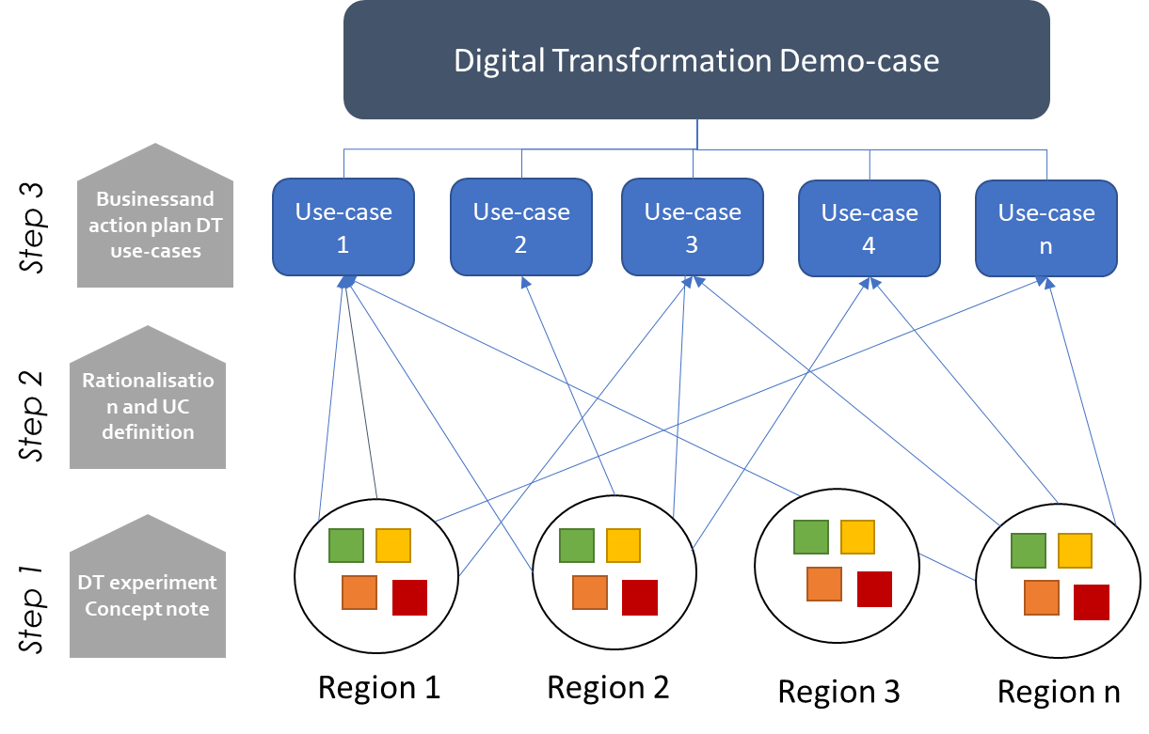
Experiment Title
[Experiment name] is an [SME/DIH]-driven experiment in [Region], led by [Experiment leader] and focused on [Experiment cluster].

EXPERIMENT CONCEPT

General description and motivation
Give a general description of the experiment, including:
- Motivation - problems, gains and pains;
- Experiment concept;
- Challenge - specify the need for Artificial Intelligence;

Expected impact & benefits
Describe the main expected impact and benefits that the implementation of the experiment is expected to provide at a business level. Highlight the expected benefits towards product quality, productivity, reduction of costs, effectiveness of processes, benefit in production, improvement in company image, or other tangible benefits.

Experiment domain
Experiment domain:
- Product Engineering and Lifecycle Management;
- Factory efficient and sustainable manufacturing;
- Quality control and predictive maintenance;
- Robotics and Human Interaction
- Other: (specify)

REGIONAL CONFIGURATION

Involved Regions (optional)
Specify the regions involved in the experiment highlighting the leading Region(s) and, if possible, other interested/participating regions.
- Leading Region(s):
- Participating(interested Region(s):

Experiment Team
Provide a brief description of all the involved stakeholders in the experiment and their role.

[Region 1]
Name of the organization | Type of organization (SME, LE DIH, University, RTO, …) | Role  (End-user, DIH, Tech-Provider, Other…) | Other comments

[Region 2]
Name of the organization | Type of organization (SME, LE DIH, University, RTO, …) | Role  (End-user, DIH, Tech-Provider, Other…) | Other comments

Quickly describe how the collaboration is expected to occur. If not all the parties have already been identified, provide a brief description of the expected partner(s) for the success of the experiment (e.g. “a solution provider able to…”).
If an interregional collaboration is already envisaged, specify the role of the different regions and the how the collaboration will occur.

BUSINESS SCENARIO

AS-IS Scenario
Give a comprehensive description of the activities related to the experiment and currently performed in the company, the state-of-the-art of the technology involved.
Images/flow diagrams that explains the whole process are welcome.

Weaknesses and bottlenecks
Describe the current problems connected to the AS-IS scenario and the possible causes. Then, fill the provided table synthetizing the main weaknesses and bottlenecks, specifying the affected business areas.

Weaknesses & Bottlenecks | Description | Business Impact Area
Name of the weakness/bottleneck | Description of the weakness/bottleneck | Which business area is affected by the weakness/bottleneck (e.g. production, marketing & sales, R&D, ..)? How?
Table 1 – Weaknesses and bottlenecks

TO-BE Scenario
Give a comprehensive description of the expected solution, listing all the possible targeted scenarios. Clarify how the activities will be performed after the implementation of the experiment and specify the use of AI technologies/applications.
Images/flow diagrams that explains the expected process are welcome.

Expected results and KPIs
Describe the main expected results after the implementation of the experiment. List in the following table the main expected Business Objectives and the related KPIs that will be used to monitor the experiment progresses.

Business Objectives (BO) | KPIs
BO 1 | KPI(s)
BO 2 | KPI(s)

Table 2 – Business Objectives and KPIs

INFRASTRUCTRAL AND TECHNOLOGICAL MAPPING

Experiment infrastructures and technologies (AS-IS)
Describe existing infrastructures and technologies available in the region for the experiment.

Name of the organization | Available Infrastructures | Available technologies
E.g. Competence center | CC Lab | HR/VR

Needs and barriers
Describe the main needs and barriers foreseen to reach the TO-BE situation and achieve the expected results. Specify what is missing in terms of competences, technologies, infrastructures,…

